GLOBAL ECONOMY

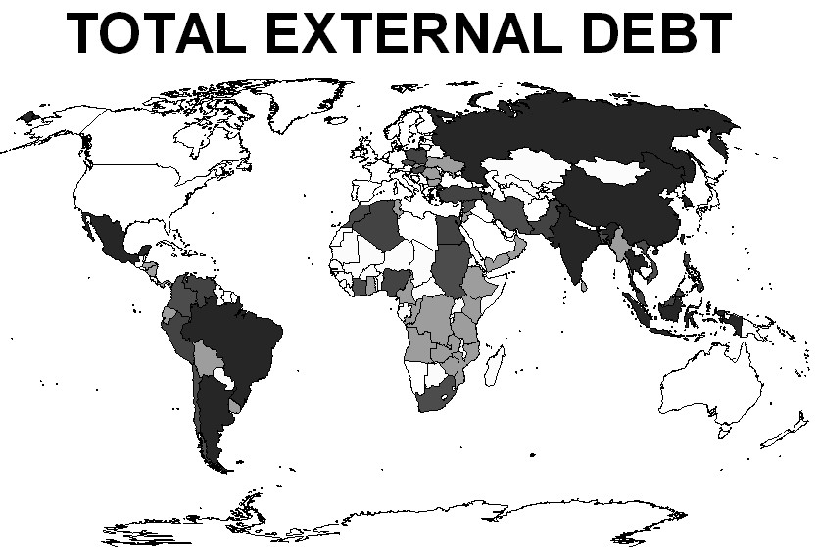



Arc View Lesson
GIS Information

Here's a list and explanation of important features in ArcView:

Project : In ArcView, a file for organizing your work. Projects use five types of
documents to organize information: views, tables, charts, layouts, and scripts.

View : A component of an ArcView project used for displaying, querying, and
analyzing geographic themes.

Table of Contents: All themes in a View are listed to the left of the map. The Table of
Contents shows the symbols used to draw features in each theme. The check box next to each theme indicates whether or not it is turned on or off in the map (whether it is currently drawn on the map).

Theme: A set of related geographic features, such as streets, parcels, or rivers, and the
characteristics (attributes) of those features.

Tables : Information formatted in rows and columns. A component of an ArcView
project used for displaying Tabular data.

Layout : The design or arrangement of elements in a digital map display or printed
map. A component of an ArcView project used for creating presentation-quality maps.

Hotlink: In ArcView, a way to display data (for example, a file, image, ArcView
document, or project) directly from a view, by clicking on a feature.

ArcView Buttons Reference Guide

View - Buttons
 | Save Project |  | Add Theme |  | Theme Properties | Edit Legend | Open Theme Table |  | Find | Locate Address | Query Builder |  | Zoom to Full Extent | Zoom to Active Theme | Zoom to Selected | Zoom In | Zoom Out | Zoom to Previous Extent |  | Select Features using Graphics | Clear Selected Features |  | Help

View – Tools
 | Identify | Pointer | Vertex Edit | Select Feature | Zoom In | Zoom Out | Pan | Measure | Hot Link | Area of Interest | Label | Text |  | Drawing and Editing Tools |  |  | Scale |  |  | Coordinates

Push and hold to select tool
Point
Line
Polyline
Rectangle
Circle
Polygon
Line Split
Polygon Split
Auto Complete

Table - Buttons
 | Save Project |  | Cut | Copy | Paste |  | Select All | Select None | Switch Selection |  | Create Chart |  | Find | Query Builder | Promote | Join |  | Summarize | Calculate |  | Sort Ascending | Sort Descending | Help

Table - Tools
Record Counter | Select Tool | Edit Tool | Identify Tool

Chart - Buttons
Save Project |  | Undo Erase |  | Area Chart Gallery | Bar Chart Gallery | Column Chart Gallery | Line Chart Gallery | Pie Chart Gallery | Scatter Chart Gallery | Chart Properties | Series From Records/Fields | Find | Help

Chart - Tools
Identify Tool | Erase Tool | Erase Within Polygon Tool | Chart Element Properties Tool | Chart Colour Tool

Layout - Buttons
Save Project | Cut | Copy | Paste | Layout Properties | Group | Ungroup | Bring to Front | Send to Back | Undo | Zoom to Page | Zoom to Actual Size | Zoom to Selected | Zoom In | Zoom Out | Print | Help

Layout - Tools
 |  | Pointer Tool | Vertex Tool | Zoom In Tool | Zoom Out Tool | Pan Tool | Text Tool | Drawing Tools |  | Frame Tools

Push and hold to select tool
View Frame
Legend Frame
Scale Frame
North Arrow Frame
Chart Frame
Table Frame
Picture Frame

For more Information: http://www.esricanada.com

Getting Started

Before you begin, the lesson data folder must be copied into a drive in which the student has writing and editing capabilities. This will probably be the drive containing your own personal account on the school’s system or it may be the C: drive of the machine you are currently working on. If the latter is the case you will have to work on the same machine each day until this assignment is complete. Each school set-up is different so work with your teacher to prepare your data folder.

! (The data for the lesson must first be downloaded from this Web site and placed on the school computer or network. Ask your teacher where to find the data folder that has been downloaded).

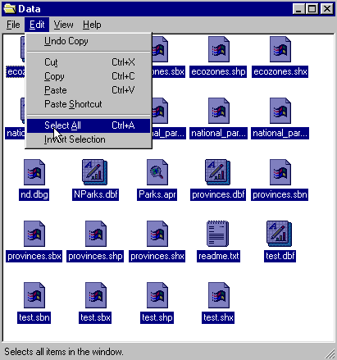To do this, use the file manager program on your computer. For Windows-based systems this will be My Computer / Windows Explorer /.

Once the data folder has been copied to the required destination the files must be made usable by removing the read only attribute. For Windows-based systems follow these instructions:

! (The data downloaded from the Web Site is set as read only so that it cannot be changed or altered by accident.)

1. Open your new data folder.
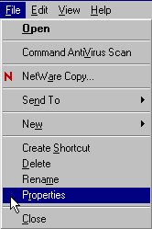2. Choose Edit > Select all (they will all appear Blue)

3. From the menu choose:
File > Properties

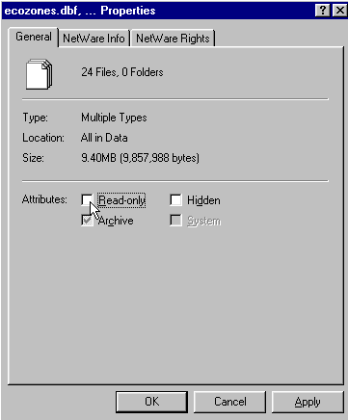

4. Remove the check mark in the
box beside the label read only.

5. Click Apply, then OK.

The data in your new data folder can now be opened, edited and saved using ArcView or other GIS software that can use SHAPE files to carry out the following project.

! Denotes an observation.
? Denotes a question to be answered on the Student Activity Sheet.

STARTING THE PROJECT

This lesson will emphasize the use of geomatic data to study several aspects of the global economy, gross domestic product, income disparity, poverty, external debt, and foreign investment.

STARTING ArcView

Begin by starting up the ArcView program. If you are not sure how to do this, ask your teacher.

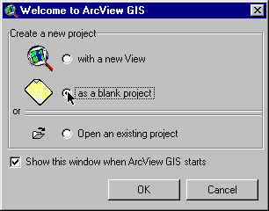
1. Choose as a blank project
2. Click O.K.

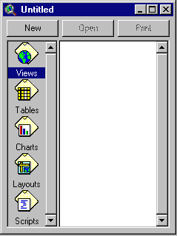When the program starts, it automatically opens a project window titled "Untitled."

If you like, you can maximize the ArcView window to fill the screen.

! In ArcView, you work within a project. A project is a collection of documents (map views, tables, charts, layouts, etc), document user interfaces, (called DocGUIs) and scripts. Only one project is open at a time.

3. Now you are ready to add documents to your new project.

4. With the “Views” icon selected, click on New and
maximize the View1 window.

5. Click the Add Theme button and navigate to the data folder where your data is stored. Hold down your SHIFT key and select the following files:

base.shp
ext_debt.shp
for_invest.shp
gdp_pc.shp
gini.shp
poverty.shp

6. Click O.K.

This will add these six themes to the table of contents of the new view. They are now available for display and editing.

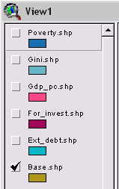
7. Click and drag to move the themes up or down in the table of content to change the order of display if necessary.

! Note the themes are displayed from the bottom to the top so line and point themes should be on top of polygon files to be visible.

8. Click on the square next to the themes you want to display. The theme that appears raised in the table of contents is the current active theme. This can be change by clicking on other themes.

9. Remember to Save your project as you go along. Go to the File menu and select Save Project. Save your work to the appropriate directory (ask your teacher if you are not sure). Give your project a name that will identify your work. (The suffix .apr means that you are saving your work as a project that can be opened up in the future).

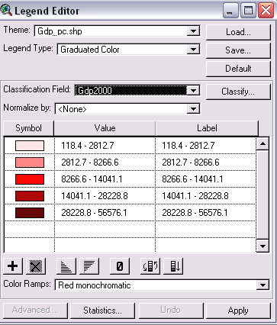

ArcView - DISPLAYING A MAP

Mapping Gross Domestic Product Per capita

1. From the Project window select the Views icon.
2. Select and open View1.
3. Double Click the gdp_pc.shp theme to edit it.
4. Open Legend Type list.

5. Select Graduated Colour.
6. Open Classification Field list.
7. Select gdp2000

8. Click Apply.

9. Close Legend Editor window.

! This will display the gross national product per capita for each country in Constant 1995 US dollars per person. Data are missing for some countries.

? Can you see the distribution of developed countries, developing countries and under developed countries?
Use the zoom button to look at Europe.
? Describe the pattern in the GDP you see in the Europian region?

Use the Identify Tool to query a country to get its name and other details.

Redisplay the map using different years. Eg.(gdp1995, or gdp1987)
? Describe the change in maps and provide possible reasons for the changes?

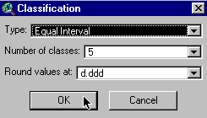
ArcView - CLASSIFYING A MAP

1. Double Click the gdp_pc theme.
2. Click Classify.
3. Select Type Equal Intervals.
4. Click O.K.
5. Click Apply.
6. Close Legend Editor window.

? How did the map and legend change?

Repeat this process using different classification types.

? How did the map and legend change with the diiferent classication types?

? Why is it important to select the proper classifcation?

ArcView - DISPLAY DATA AS CHARTS

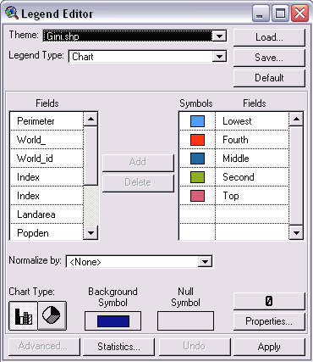
We will now display income disparity using charts.
The data used show the share of the total income for the lowest, fourth, middle, second and top 20% of the population.

1. Double Click Gini theme.
2. Open Legend Type list.
3. Select Chart.
4. In the Fields List, Select Lowest.
5. Click Add.
6. Repeat for Fourth, Middle, Second, and Top.
7. For Chart Type Click Bar Chart.
8. Double Click Background Symbol and Select a Background Symbol that does not conflict with your legend colours.

9. In the Legend Editor window, Click Properties to alter the look of the charts.
10. Click OK.
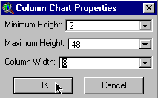
11. Click Apply.
12. Close Legend Editor window.
? By zooming in and comparing the charts, can you describe the graphs of several countries?

? What does this tell you about income equity?

! Plotting distribution: Lorenz curves and GINI index:
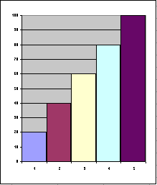
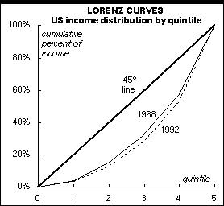
We can start with the nearby graph, derived from the numbers in the table. The horizontal axis shows the quintiles; the vertical, the cumulative share of income earned by the plotted quintile and the ones below it. For example, for 1968, the cumulative value for quintile 1 is the share earned by quintile 1, or 4.2%; that for quintile 2, 11.1%+4.2%, or 15.3%; and so on, up to quintile 5, when the sum is 100%. The graph plots these values for 1968 and 1992. These lines are called Lorenz curves.
In a society with perfectly equal income distribution, the cumulative share of income would be equal to the cumulative population share: e.g., the value for quintile 2 would be 40% (20%+20%), instead of 1968's actual 15.3%. This mythical egalitarian society is represented by the heavy 45° line. A bar chart similar to those on the map for the mythical egalitarian society would look like the sample chart below.
The gap between the actual lines and the mythical line is a function of the degree of inequality; the 1992 line is further away from the heavy line than 1968's is. The Gini index measures the gap between the actual line and the 45° line. In the egalitarian society, the Gini would be 0.000, since the Lorenz curve would match the 45° line perfectly; the higher the Gini, then, the greater the distance, and the more unequal the distribution of income. In a perfectly unequal society, in which one person (or household or family) had all the income, the Lorenz curve would look like a backwards "L," and its value would be 1.000. In practice, the Gini usually falls between 0.200 and 0.450. The U.N. uses a Gini value of 0.4 as a warning level that a countries economic disparities are becoming excessive.
? Select several countries and compare the charts and data with the mythical ideal graph presented above. What can you say about the income inequity in each of the selected countries?

Use the Identify Tool to query five countries to get the data needed to prepare Lorenz curves.

? After plotting the data as Lorenz curves can you describe the income equity for each of the countries?

ArcView - BUILDING A QUERY

We will now build a query to explore the level of external debt held by each country. The data are presented (in Million current US dollars)

1. Double Click the ext_debt.shp theme to edit it.
2. Open Legend Type list.

3. Select Graduated color.
4. Open Classification Field list.
5. Select T2000.

8. Click Apply.

9. Close Legend Editor window.

! This layer has the total external debt carried by each country 1987 to 2000.

Now lets build a query to find all the countries with a total external debt greater than $10 billion in 2000.
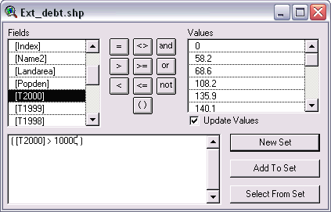
1. Select and activate ext_debt theme. 2. Click Query Builder button.

3. Double Click Field T2000.

4. Click the > button.

5. Enter 10000 in the equation.
6. Click New Set button.
7. Close query window.

? List five countries that had an total external debt greater than $10 billion?

? Describe the global pattern of external debt over $10 Billion in 2000?

8. Click Clear Selected Features button.

Using the same process as used for 2000, choose other years and or debt limits.

9. Click Query Builder button.

10. Double Click Field T1987.

11. Click the > button.

12. Enter 15000 in the equation.
13. Click New Set button.
14. Close query window.

? List five countries that had an total external debt greater than $15 billion in 1987?
? Describe the global pattern of external debt over $15 Billion in 1987?

Let's build more querries to explore total external debt.
ArcView - DISPLAY PERCENTAGE DISTRIBUTION

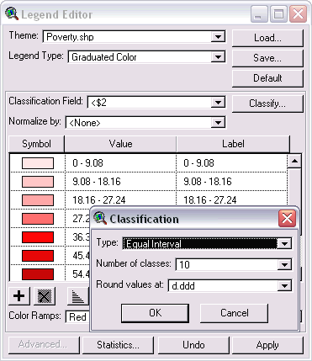
We will display poverty as the percentage distribution of country population earning < $2 and < $1 a day 1994 to 1999.

1. Double Click Poverty theme.
2. Open Legend Type list.
3. Select Graduated Colour.
4. Open Classification Field list.
5. Select <$2.
6. Click classify button.
7. Open Type list.
8. Select Equal Intervals and 10
classes.
9. Click OK.
10. Click Apply.
11. Close Legend Editor window.

? What can you say about the global distribution of Population living below $2/day?
? Are there regions not represented?
? Why?

! To have a completed map, we will put a no data item in our legend for those ecozones that do not have representation.

12. Double Click poverty theme.
13. In the Legend Editor window, Click on the Null Value button.
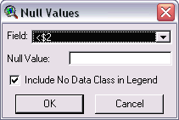

14. Check Include No Data Class In Legend box
15. Click OK.

16. Double Click no data legend item.

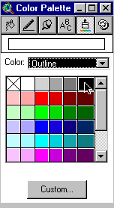

17. Click The Colour Palette button.
18. Select a new colour for the no data legend item.
19. Open The Colour list, Select Outline.
20. Select black for outline colour.
21. Close Colour Palette window.
22. Click Apply.
23. Close Legend Editor window.

! Using the same process that was used to display Population living below $2/day, display the Population living on less than $1/day. Explain the distribution patterns you see.
? Explain the distribution patterns you see for poverty.

ArcView - MAP LAYOUT FOR PRINTING

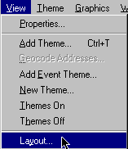
Once you have a map classified and displayed to your satisfaction, you should prepare a map layout that can be used for printing. The purpose of this lesson is to set up your map on a page and annotate it for presentation.

Set up map

1. Click Menu View.
2. Click Layout.
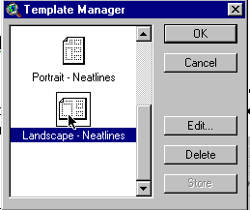
3. Select the Layout Template you want to use
(One of the landscape templates is suggested) .

4. Click O.K.
5. Maximize the Layout screen.

EDIT TITLE

1. Double click on the title View1.
2. Edit the title to reflect the purpose of the map, e.g., forestry, and population.
3. Click O.K.
4. Resize the title using the corner handles and move it into a position that is visually balanced.
5. Click and drag to reposition the legend if necessary.

EDIT NORTH ARROW

1. Double click on the north arrow and select a different presentation. Ensure that the arrow is pointing in the representative north direction of the map.
2. Click and drag to reposition or rotate (using rotation function) as needed.

EDIT SCALE BAR

1. Double click the scale bar.
2. Choose a new style of scale bar. The scale bar has default properties so you will not be able to change everything to the way you want.
3. Change the units to kms.
4. Find a combination of style, scale and divisions that is visually pleasing.
5. Click and drag to position to an appropriate location.

ADD LABELS, TEXT, OTHER INFORMATION

1. Click on the Text tool.
2. Click at the position on your layout where you want the text to appear.
3. In the Text Properties box, enter your text, e.g., “produced by (your name, date)”.
4. Select desired formatting information such as alignment, spacing and rotation.
5. Click O.K. when it appears, as you want it.
6. Click on Pointer tool.
7. Select the new text
8. Click once to change location or size. Click twice to change content.

! Experiment with all of the components of the layout until you have the look you want.

CHANGE THE NAME OF THE LAYOUT

You only have to do this if you want to save your project on the computer or on a disk.

1. Click menu Layout.
2. Select Properties.
3. Change the “name”. Click O.K.

ARRANGING YOUR LAYOUT

! Experiment with the layout buttons (use the tools page provided at the beginning of this lesson if you are unsure of their function).
- to group (tie pieces together so they move as one)
- to ungroup (break apart the ties so that individual pieces move)
- bring to front ( change order that pieces were laid down, e.g., lines on top of polygons)
- send to back ( change order that pieces were laid down, e.g., polygons behind lines)
- zoom ( make image bigger or smaller)
- neat line (border around layout)

PRINT MAP LAYOUT

1. Click Print button.
2. Click Setup.
3. Select your printer properties as outlined by your teacher.
4. Click O.K. to print.

! Note that the map can also be saved to a printer file.

